AI in Revenue Audit - Casino
- Problem statement:
Revenue audit in Casino’s is cumbersome, a lot of manual effort, interact with multiple vendor system and finally reconcile the data to check to see the data is tally across the system. If data is not tally, then go back and find out the root cause for the dispute and fix the data by doing adjustments. The problems that revenue audit is facing today are,
- Manual reconciliation process by interacting with many different software. Eyeball or using excel to compare the data which many times prone to human errors.
- Making adjustments in more than one system is dauting task.
- Generate a report for Gaming revenue to post into General ledger
- Solution Design
Using Retrieve Augment Generation AI (RAG) approach we can solve the Revue audit problems they are facing. RAG helps to automate few tasks like reconciliation & Gaming report generation helps audit team to improve their productivity and avoid human errors.
What RAG is aiding to casino overall?
- Saves time spent on the repetitive task by automating it. Increase Productivity and Avoids costly mistakes.
- Reporting accurate Revenue to the Accounting department

- Architecture

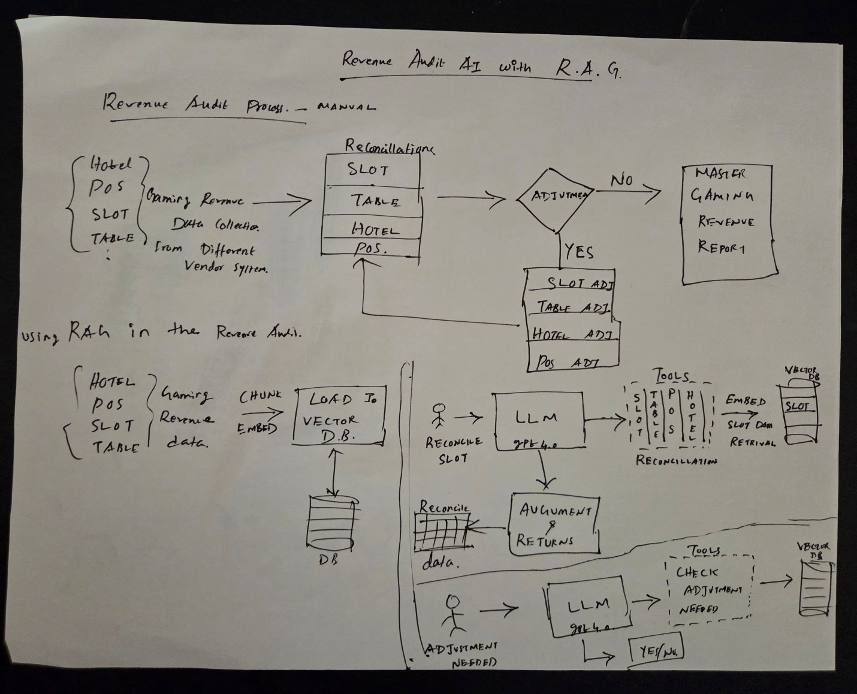

- Metrics & KPIS
KPI | With RAG | Without RAG
Productivity – Time taken to generate Gaming Revenue data | Less than 1hr | 6 to 8hrs
Adjustments – 1 week | 1 to 5 adjustments. All of the cases are true variance in the system | 15 to 18 adjustments. Includes true and false variances

